# Updated 2021-08-11 11:03:43

# Open issues

How to treat cases where midpiece-tail unclear? Note it down and try finding another sperm?

How to measure glowing pieces of sperm?

# Choosing sperm for Sperm Sizer measurements

(a) It is best to use images with a clean background, with a single sperm (or other sperm far away), and sperm cell that is not glowing much (see test image 38 - ruff 1386 2021-07-12 Snap-1509.jpg - below)

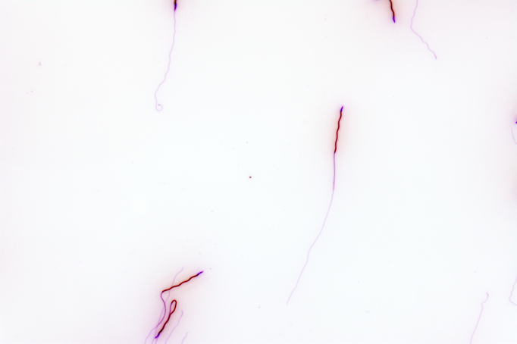

Example of poor images (glowing, with colorful background and those where sperm cells are close to each other):

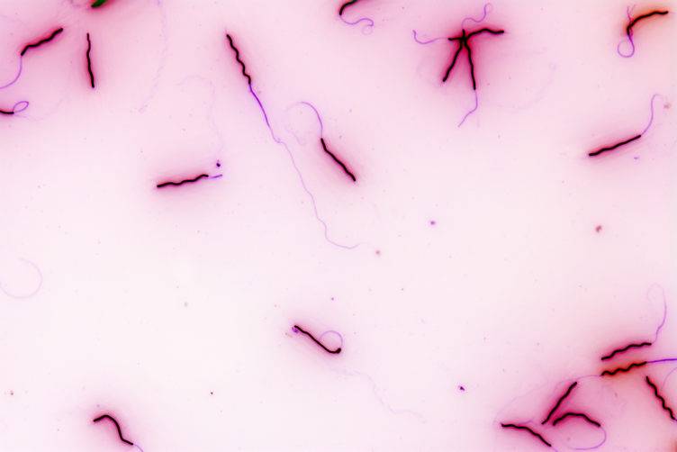 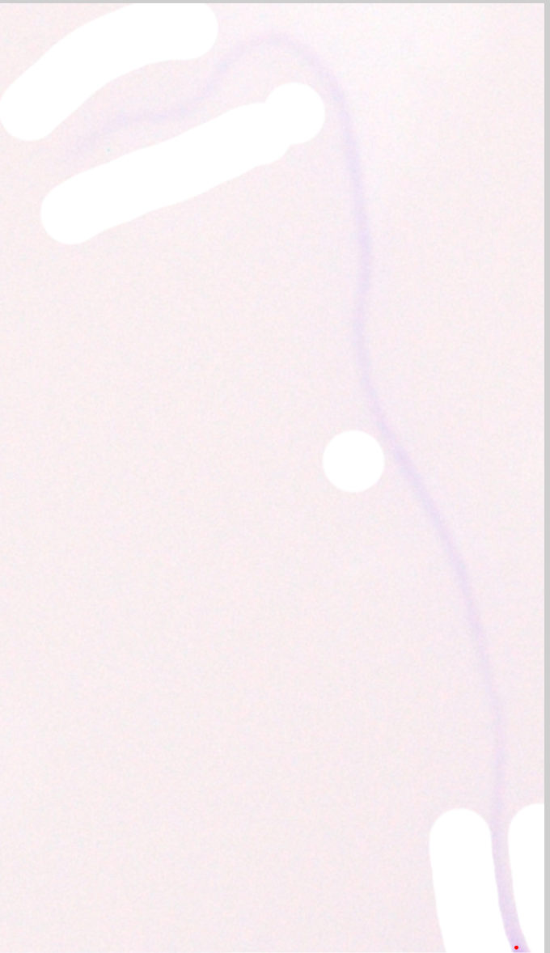 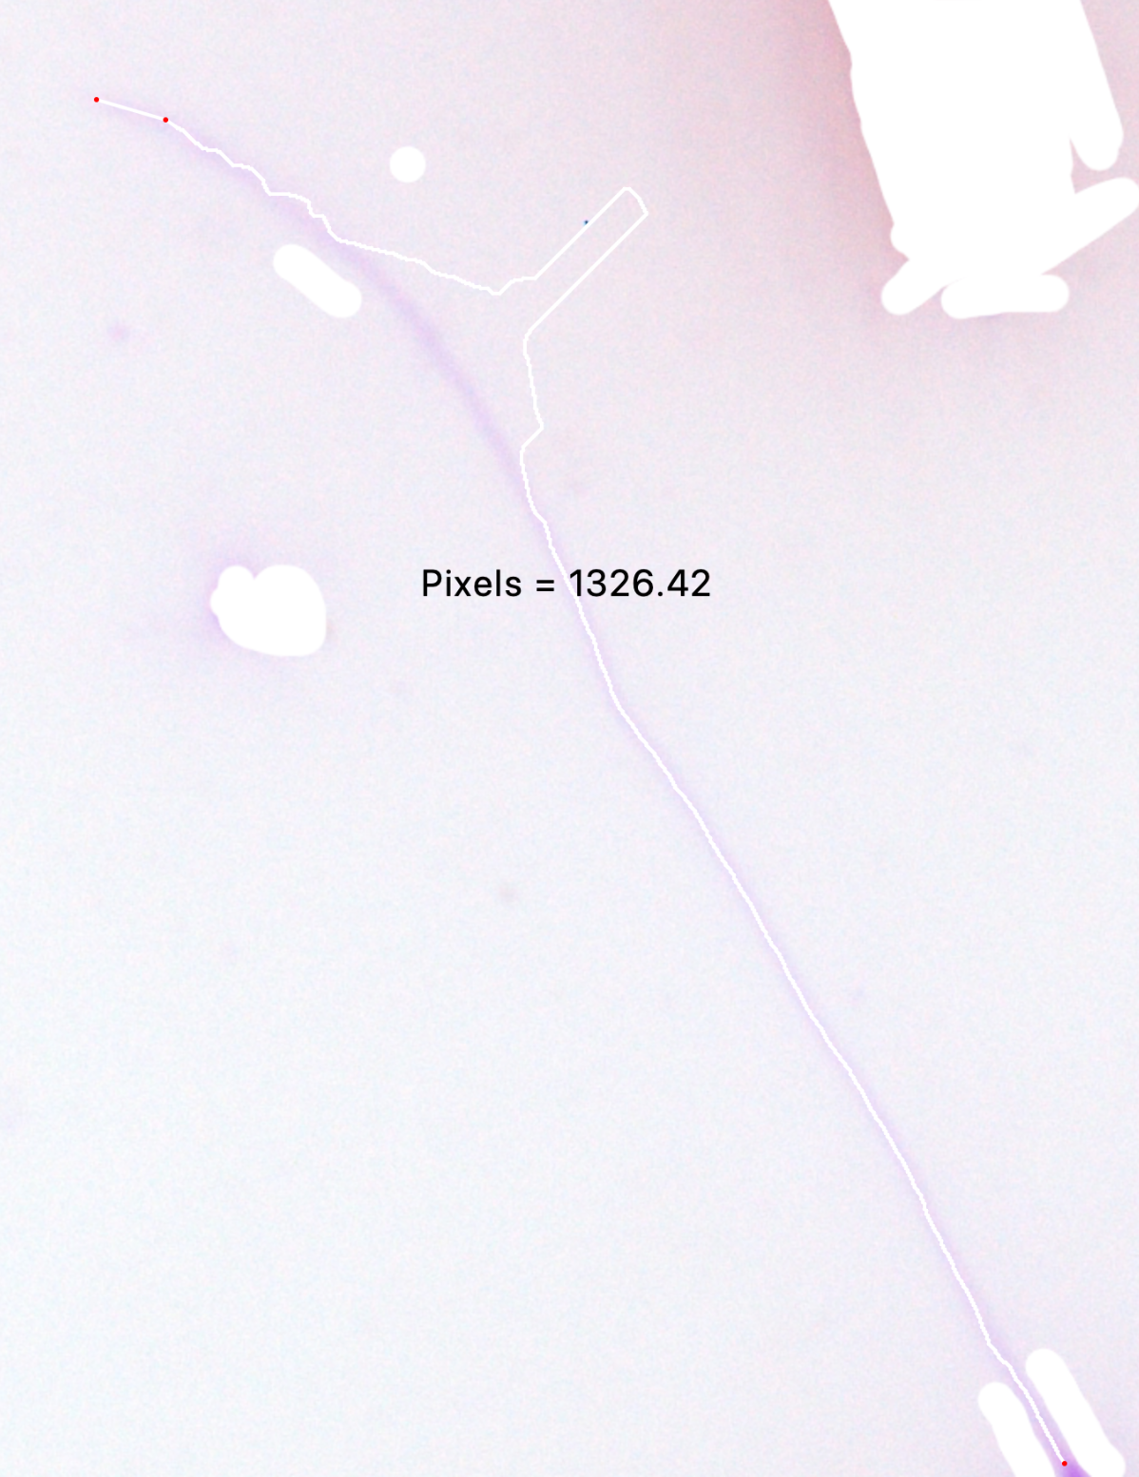

(b) If more sperm cells are on one image, it might be worth cutting single sperm cells out and measuring those on separate images.

(c) If plenty of sperm is available for a given male, let's use the best (see a-b) and ideally where tail and midpiece are distinguishable.

# Preparation of the image for Sperm Sizer measurements

All original pictures shall be in a folder ‘renamed’ and there create a subfolder ‘inverted’.

**Inverting**

Open Photoscape X, go to Batch edit and drag and drop all the pictures you wish to edit.

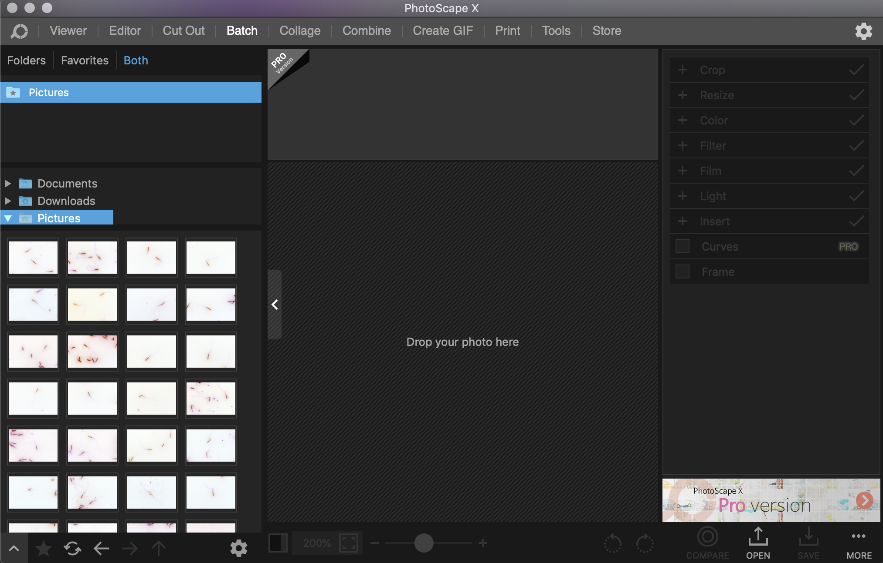

Go to ‘Color’ tab on the right and tick the box next to negative.

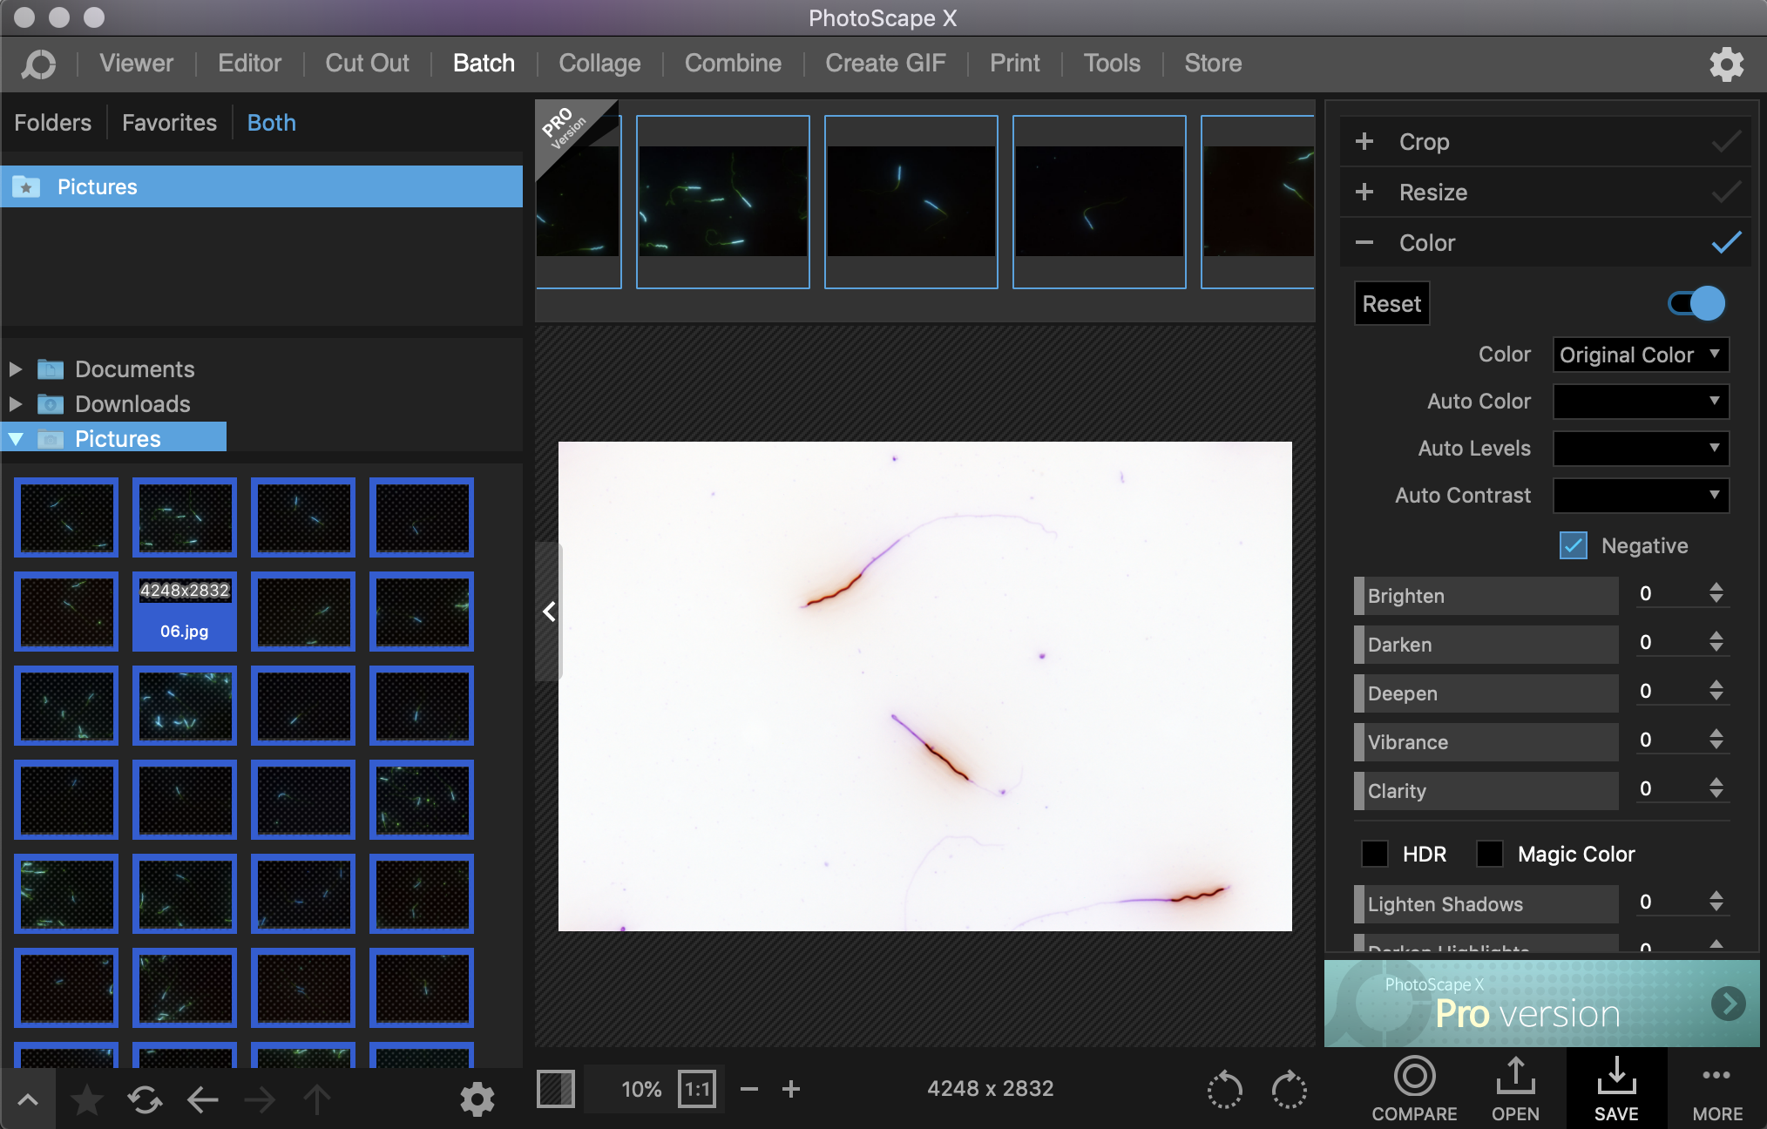

Press ‘SAVE, choose ‘PNG’ file format, JPEG Quality 100, subfolder ‘inverted’ and Suffix ‘_inv’ and press OK.

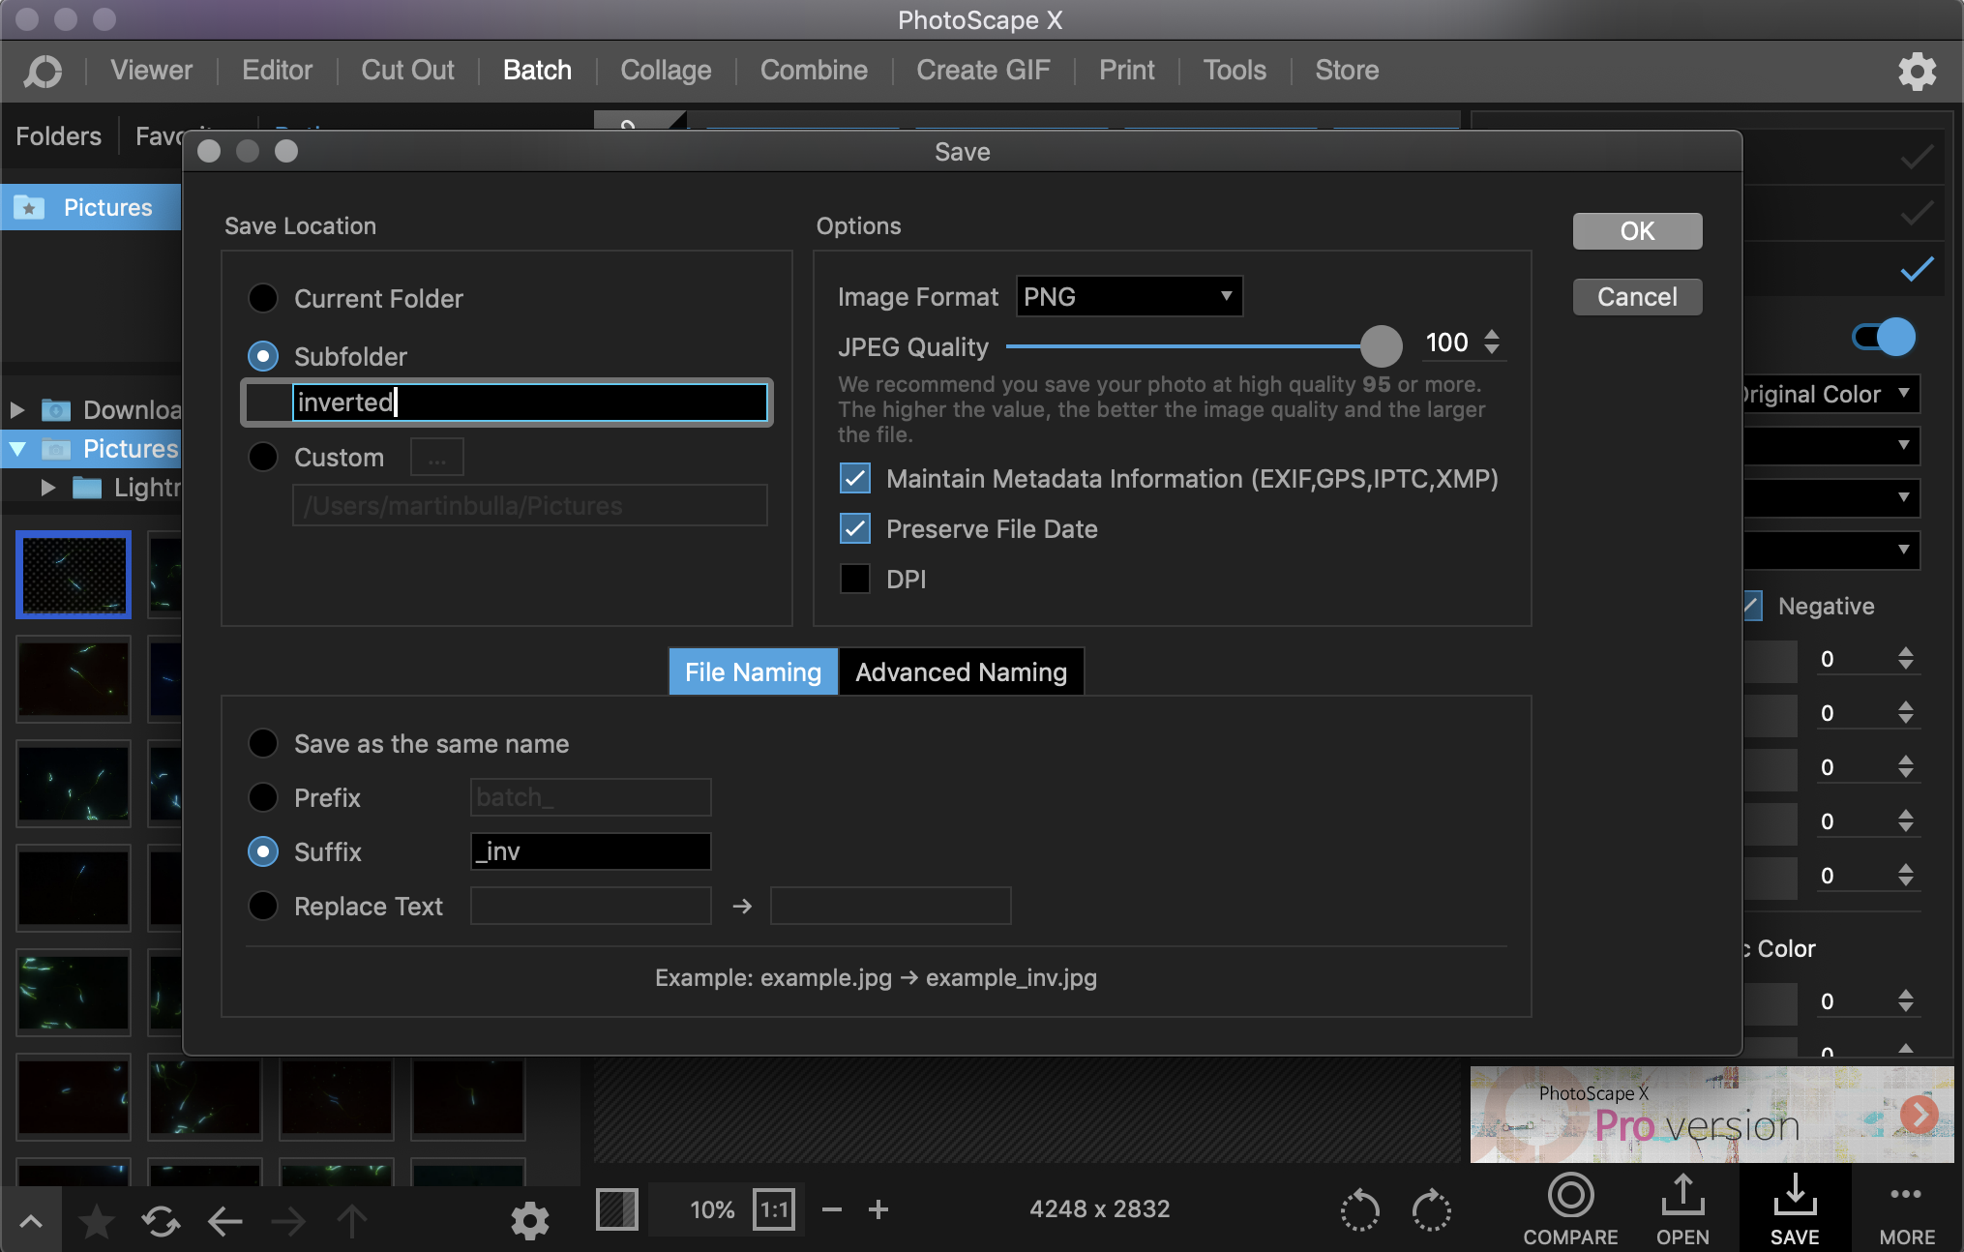

**Placing dots**

Dots are placed at the start and end of each sperm part (to access repeatability/correlation of SpermSizer and ImageJ measurements) or to standardize the start of tail when tail is measured from a differently manipulated image than the midpiece.

Create a subfolder ‘inverted_dot’ and copy there all images. Open GIMP. Drag all images into the GIMP, which will open all images at once. Assign a shortcut that will allow you to save and overwrite each image: go to Edit -> Keyboard shortcuts (on Mac to GIMP-2 -> Keyboard shortcuts), type overwrite in the search box, place a cursor in the shortcut field and press ctrl+o, Close.

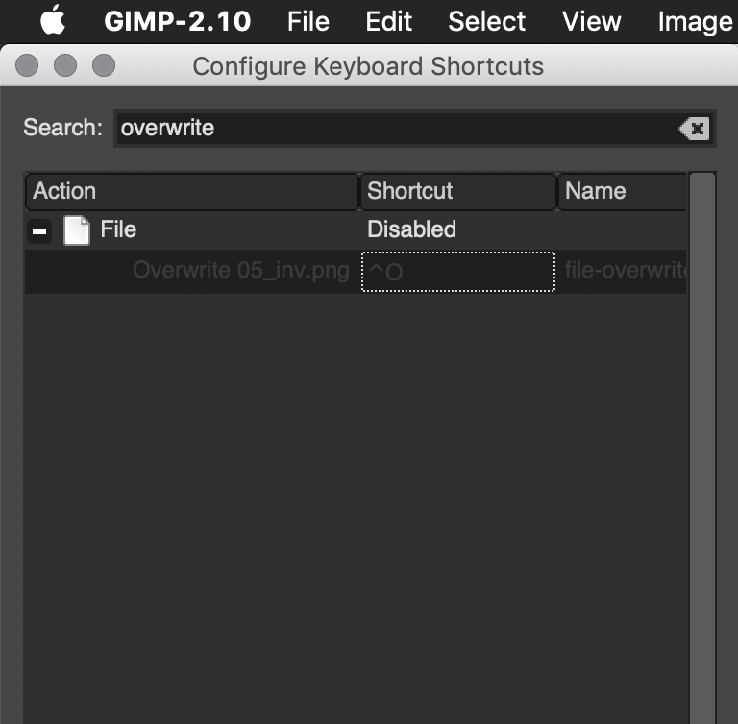

Go to an image, pick a pencil tool, set a red color and pencil size to 1 (1 pixel). Place a one-pixel dot where a part starts and ends (or only where a midpiece ends and tail starts) – you may need to zoom in with + (or mouse; on mac hold Command and use trackpad), press ctrl+o. The image with dot will overwrite the original image within the inverted_dot subfolder. Press a shortcut for closing a given image (on Mac Command + w) and in the pop-up window press discard changes. Proceed to another image. Note the saving process takes some time with PNGs, but is quick with JPEGs. Decide what format to use.

**Desaturation/grey-scale**

Open Photoscape X, go to Batch edit and drag and drop all the pictures you wish to edit (see invert section above). Go to ‘Color’ tab on the right, if ticked, untick the box next to negative and in color choose Greyscale.

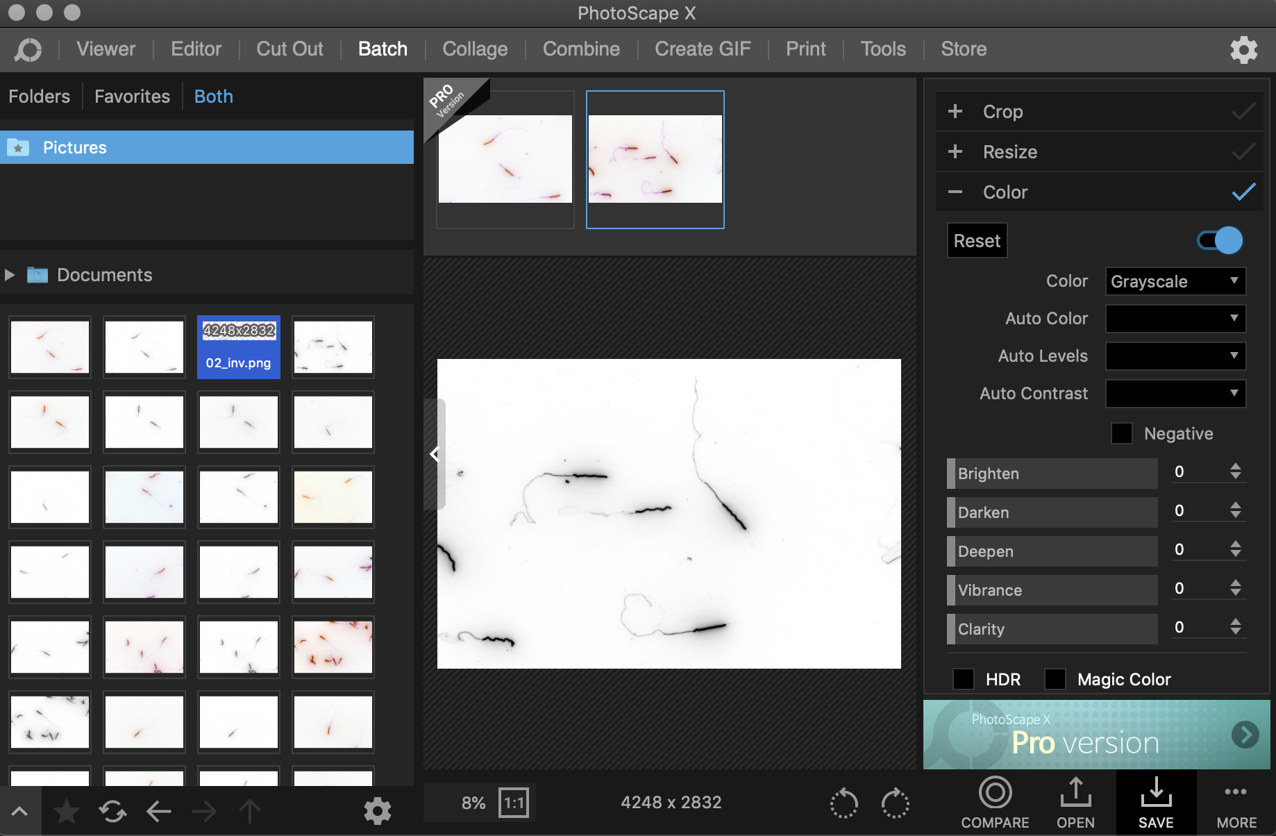

Press ‘SAVE’, use no subfolder, add Suffix ‘_des’ and press OK.

# Measuring the sperm – on SpermSizer

**Download** SpermSizer from [GitHub](https://github.com/wyrli/sperm-sizer) and read the instructions there.

**Before starting** for the first time, copy the modified config.ini into the folder with the program’s .exe file or simply modify the config.ini file so that its variables have the following values

MarkerColor=#FF0000

MarkerSize=3

LineColors=#FFFFFF

LineThickness=2

Labels=Pixels

LabelColor=#000000

LabelSize=22

LineSmoothing=4

SnapEnabled=true

TrimRadius=8

CropPadding=100

CompressCroppedImages=true

SpermSizer uses the following **control keys**

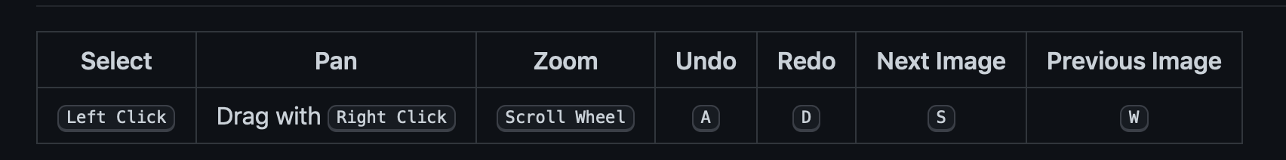

**LOADING IMAGES**

Once the program is on, **add** as many **images** as you want to measure to the Sperm Sizer.

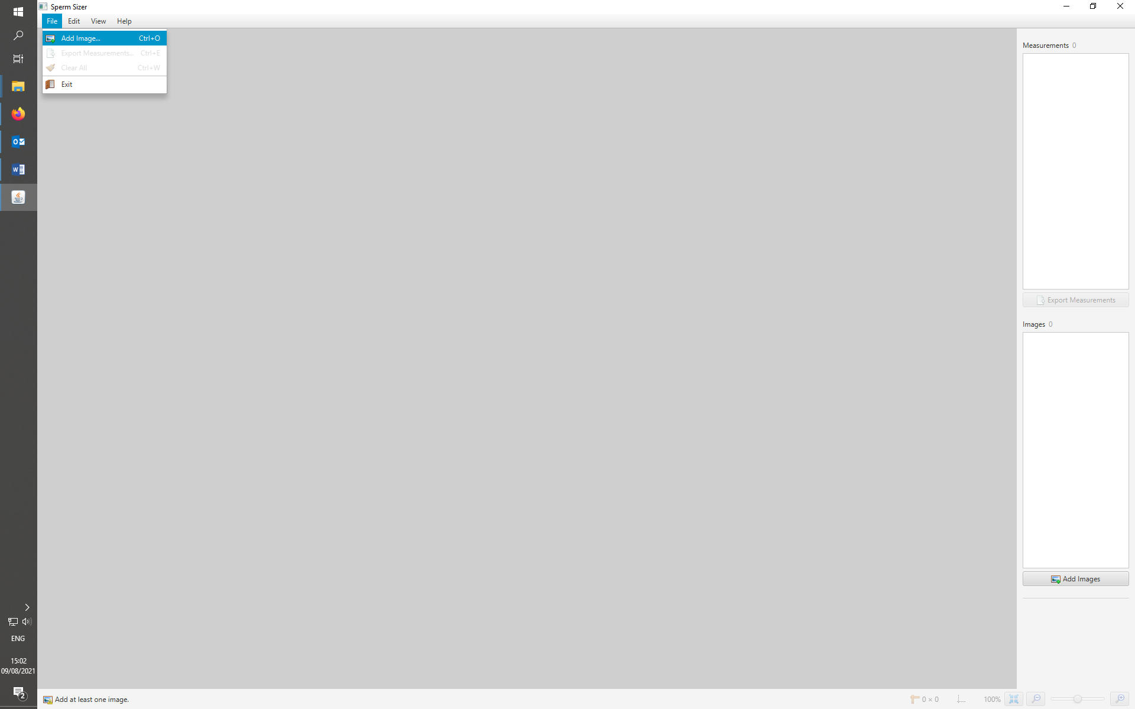

You should **add** both the **inverted** and the **desaturated version** of the image (see GIMP section above). ACROSOME, NUCLEUS and MIDPIECE will be measured on the inverted images, TAIL on the desaturated ones.

If you need to modify an image and load it into SpermSizer, you can load an image with modified name – it will be at the end of the image list or you can load a modified image that has the same name as the one SpermSizer failed to measure. In the latter case, you can further edit the image in GIMP (e.g. by erasing more of a background), overwriting the original image and loading it in the SpermSizer again. The modified image will not show, but if you click on a different image in SpermSizer and then again on the “newly” loaded one (that has the same name as the initial one), the new picture will appear. Perhaps this is a simple way to edit and measure images on the go.

**MEASUREMENTS**

Each part of the sperm is measured separately and is enclosed by the two dots you place on the sperm. The program calculates the distance in pixels as soon as you place the second dot. If the acrosome line is faded at the start, you can help SpermSizer by dragging a line from the faded start until the acrosome is easier to see and then making the dot where the acrosome ends (see GitHub [example](https://github.com/wyrli/sperm-sizer#straight-line-extensions) of this straight line extension). Same can be done with the faded tail, but in a reverse order, i.e. you place a dot where the tail starts and then drag the line from where the tail is clear until the end where it fads.

It is essential to keep the order of the measurements: Acrosome, Nucleus, Midpiece, Tail.

**IN CASE OF FAILED MEASUREMENT**

It can happen that the tail fails to be picked by the Sperm Sizer program, or that a big object adjacent to the sperm, which could be another sperm or some background dirt, induces the program to create a wrong outline of the shape of the sperm. In those cases, undo the two points defining the Tail and try again. If the tries fail, try to measure the tail on the desaturated image. If that fails as well note it down and continue. Once you are done with all other measurements, go back to images where the Tail was causing a trouble (or do it on the go as indicated above) and do the following:

**Wrong measurement due to adjacent dirt/sperm**:

Open the picture you’ve been trying to measure on GIMP. Use the eraser to clear the area that’s been causing you trouble. Export the image as PNG with suffix “era” and measure the missing part on the Sperm Sizer.

**Tail is faint:**

Open the picture you’ve been trying to measure in GIMP and use rectangle tool, to select just the tail, then go to Image tab (or right click) and choose Crop to selection.

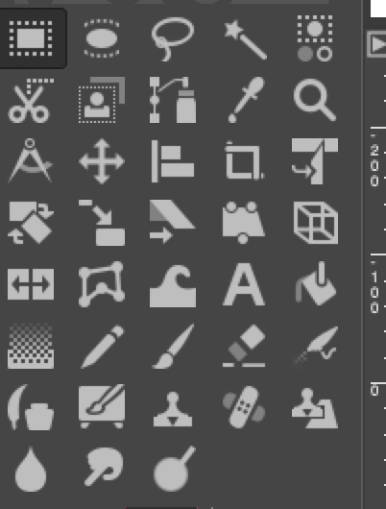

Although not always necessary, it is helpful to use eraser and erase the glowing area around midpiece, parts of tail or dirt.

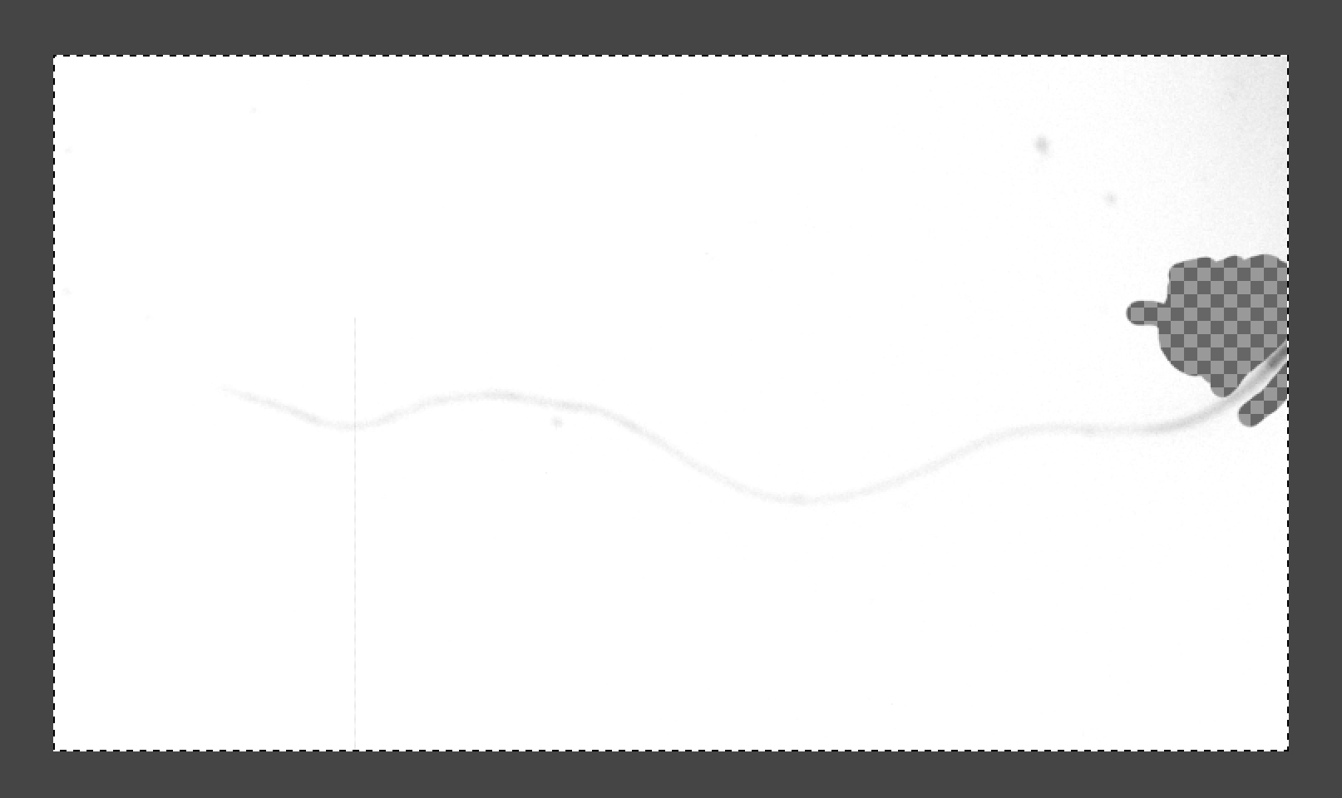 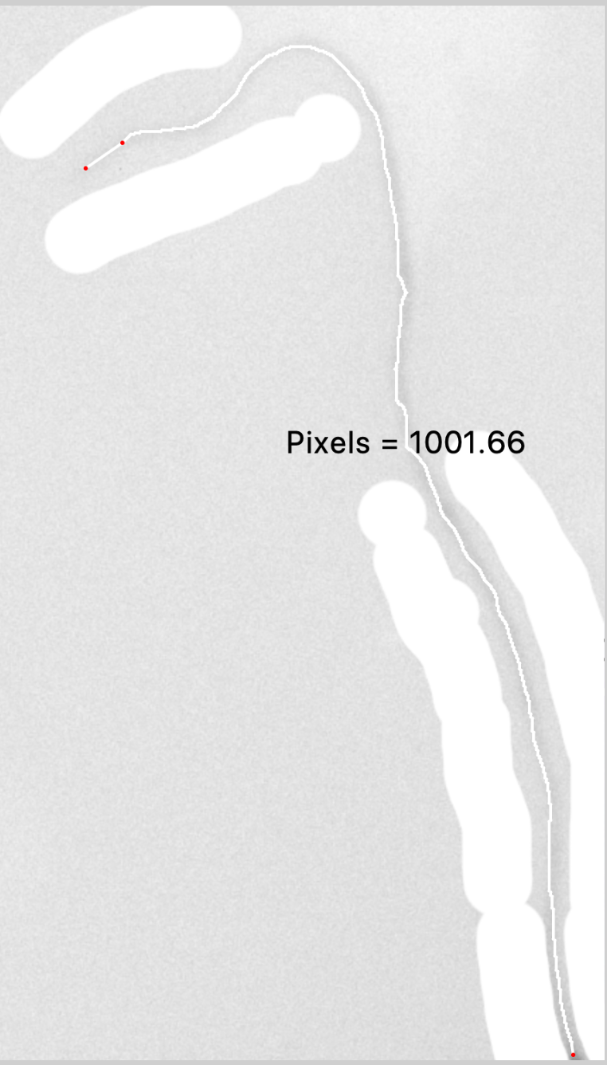

This can be done even on only inverted images, but desaturated seem to work better.

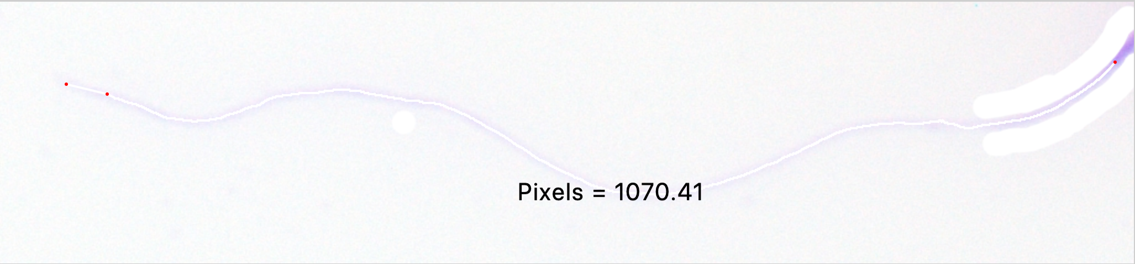

The aim is to remove unnecessary glow, even caused by other cells (see the tracking below, before and after the glow is removed).

 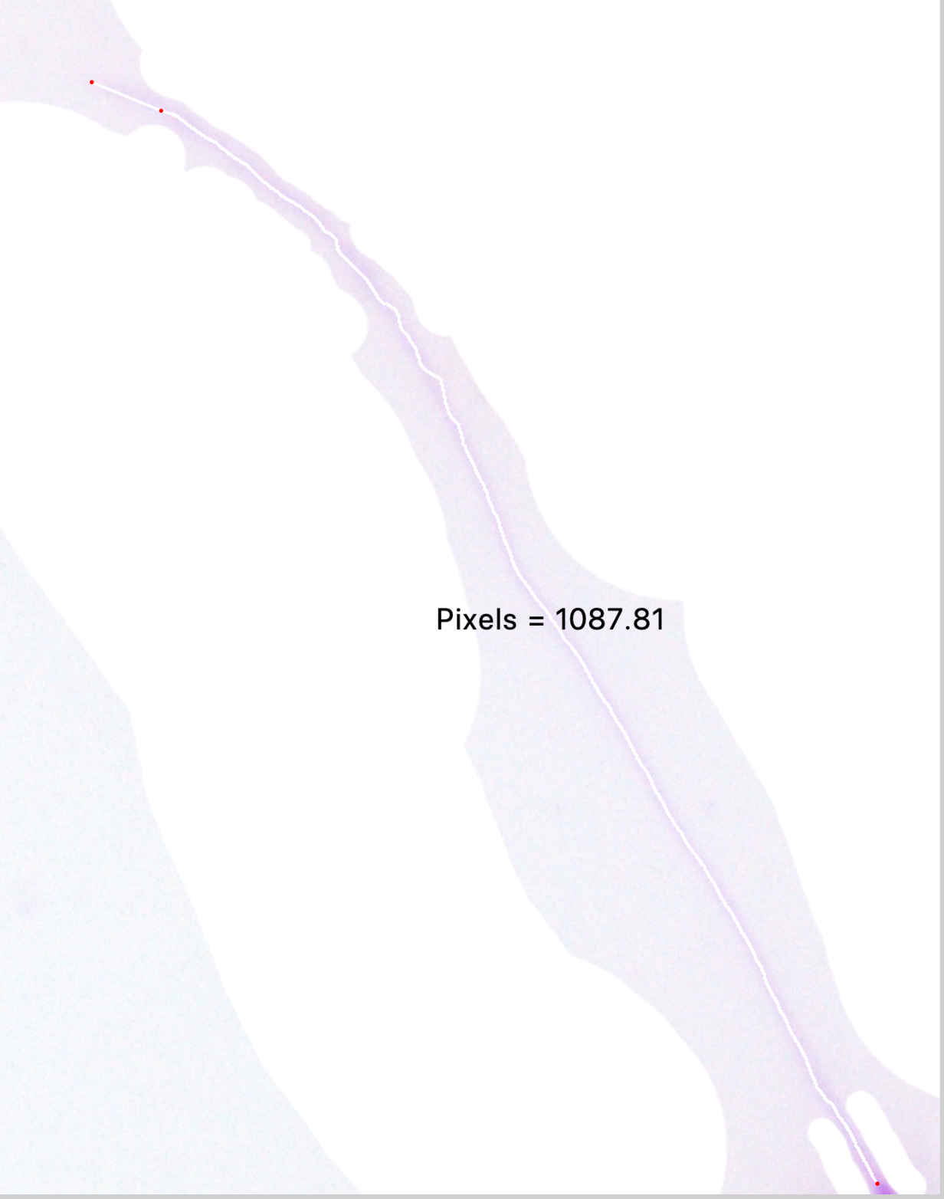

If issues persist, you can play with the contract

either by going to Colours tab and choosing Curves, taking the line and moving it to change contrast

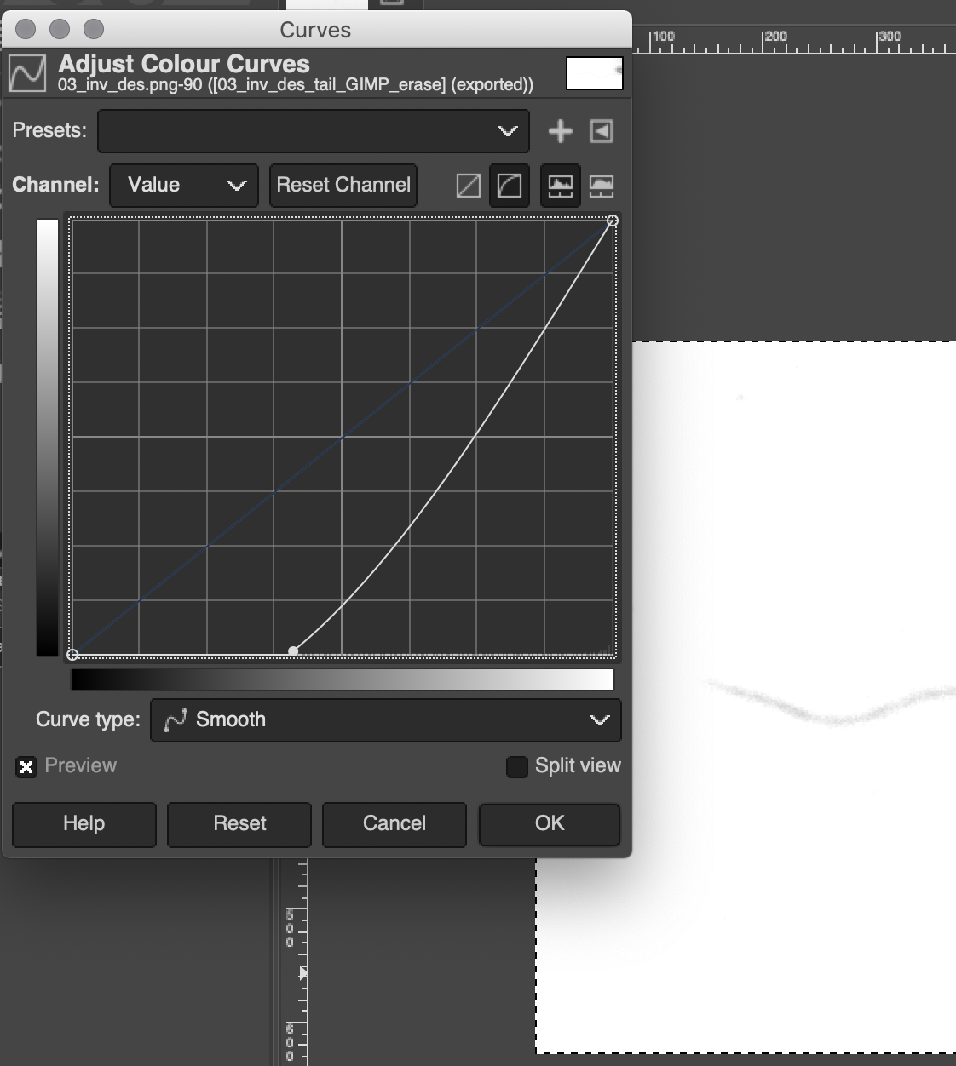

or by choosing Brightness-Contrast Once and in the pop-up window presssing “Edit these Settings as Levels”.

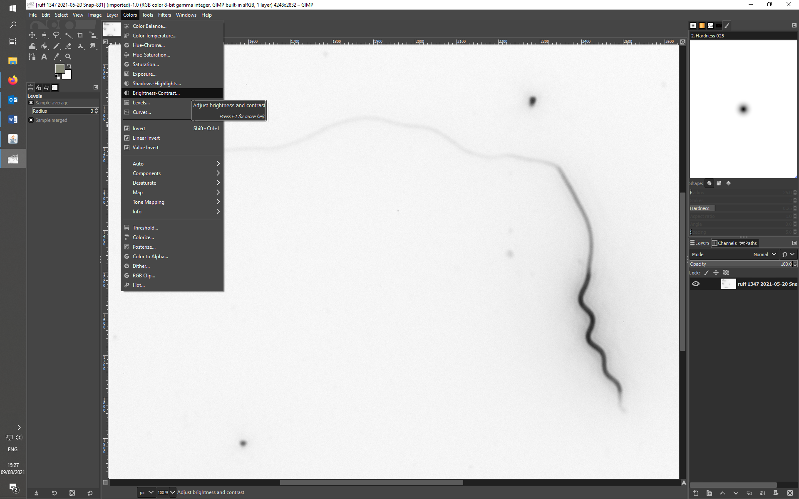

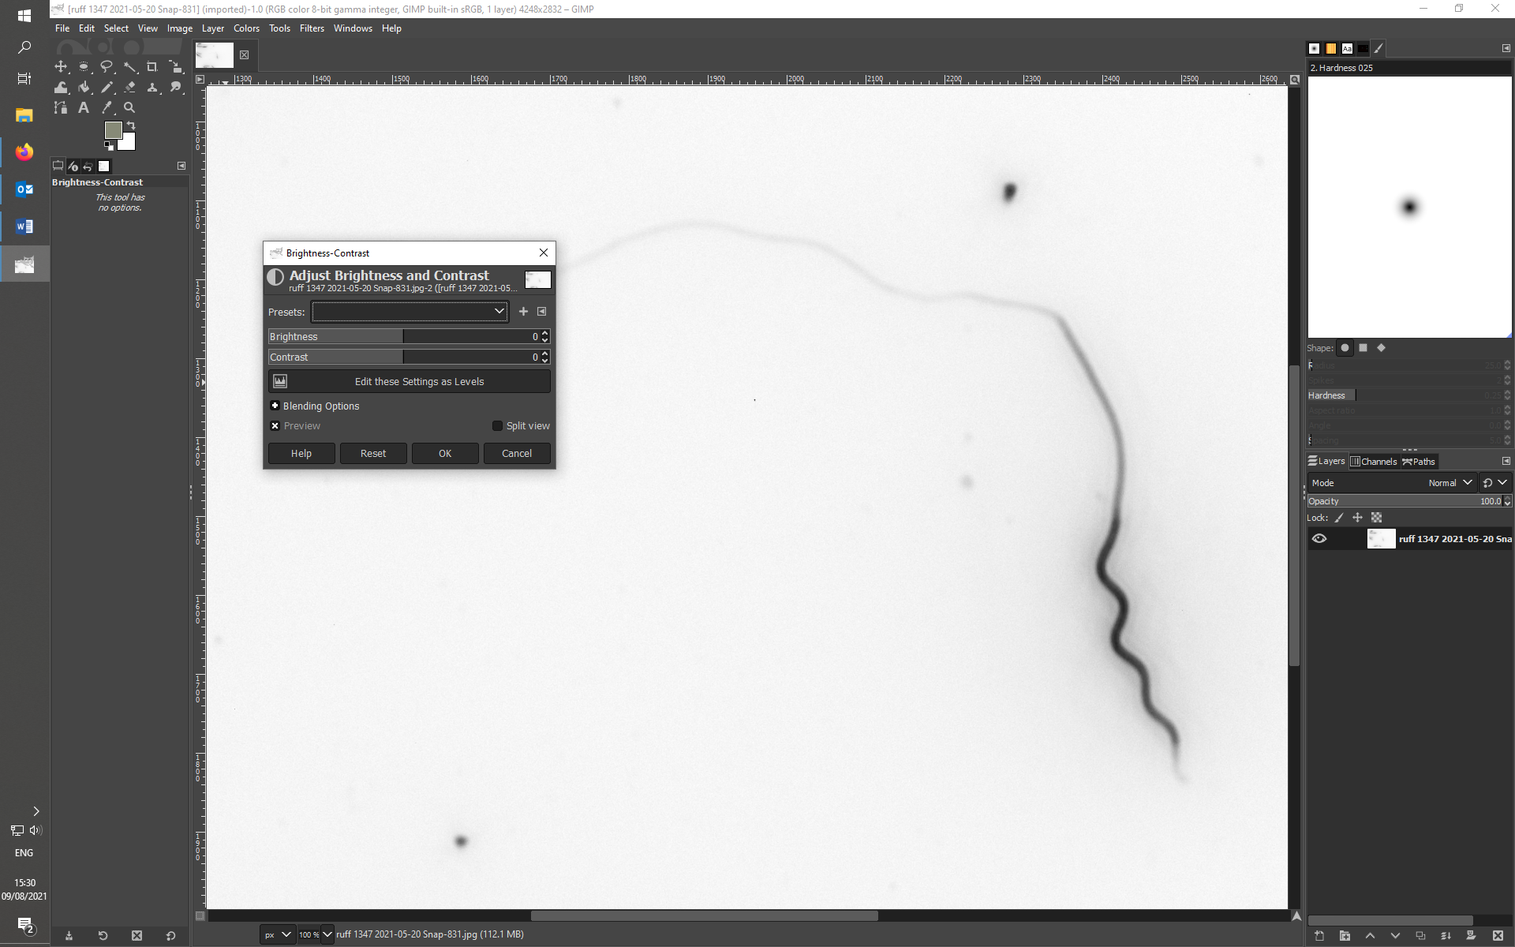

The following window will appear. You can optimize the contrast between background and subject by playing with the marked triangular lever. Try to get a better contrast but don’t exaggerate with this function. The image just needs to be a bit better for the Sperm Sizer to finally pick the faint tail.

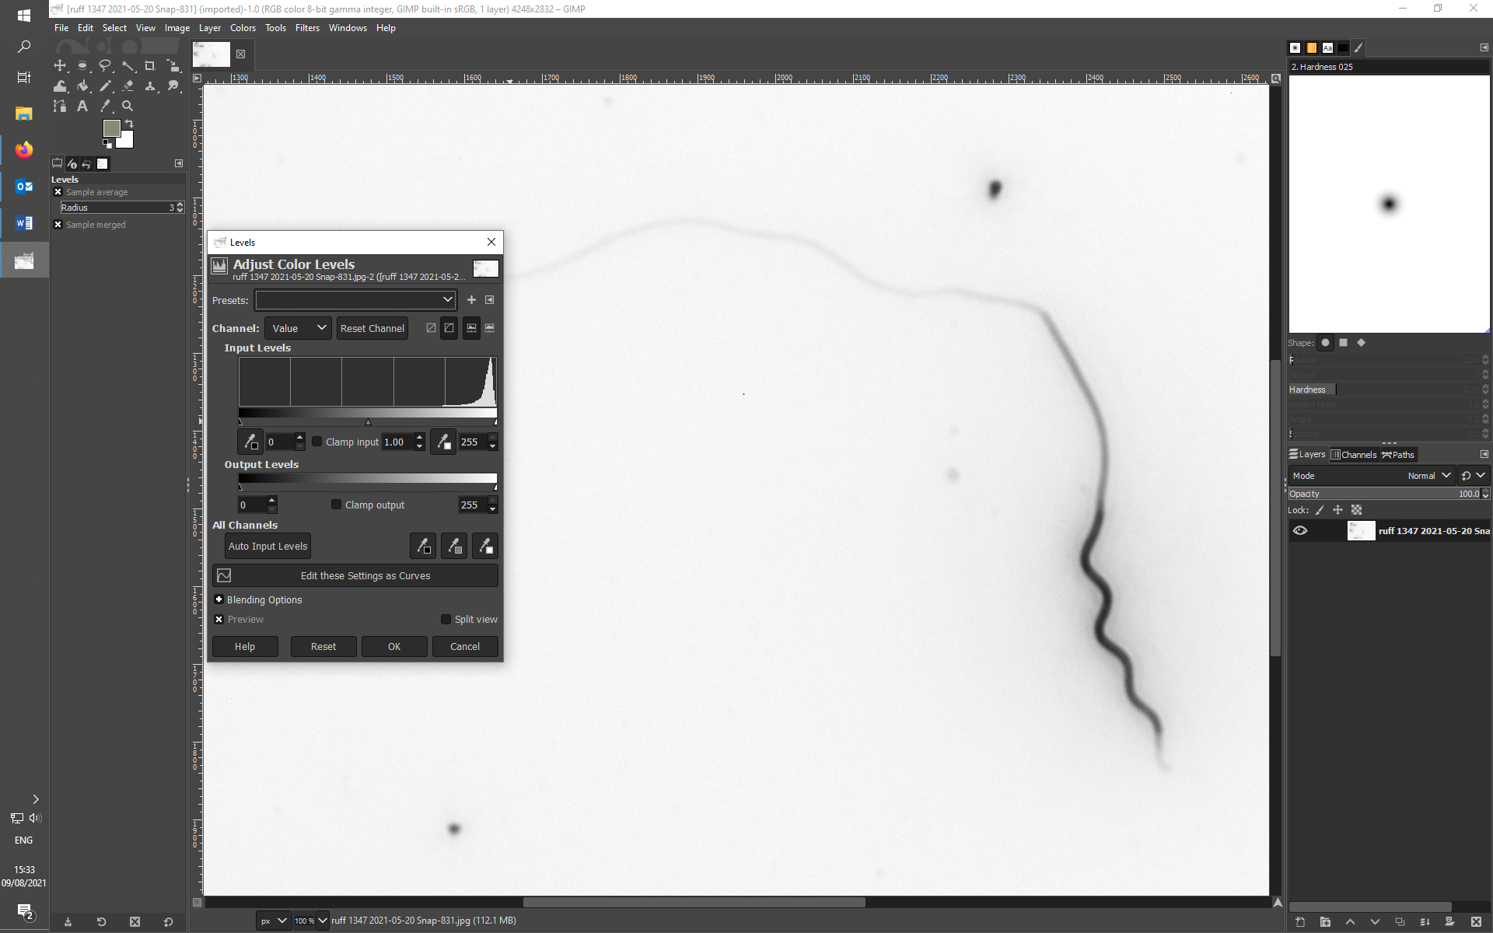 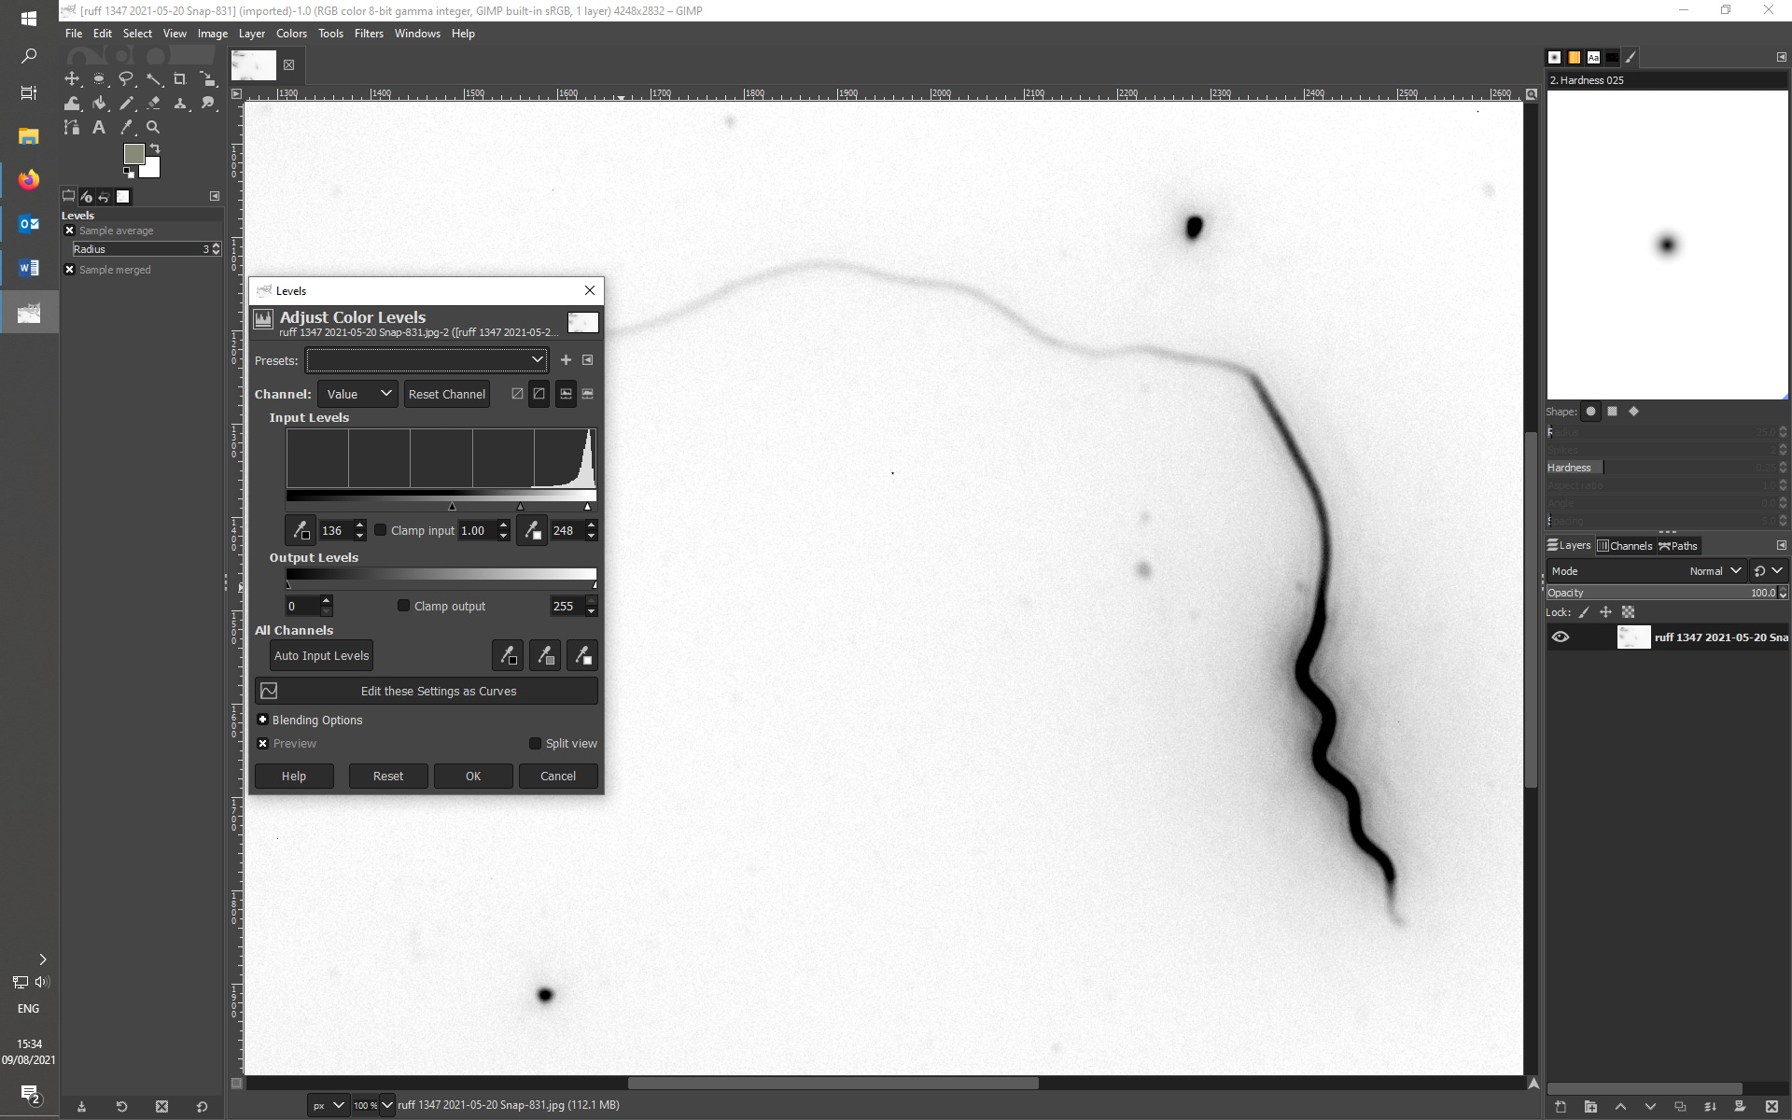

For a comparison left picture shows the imput levels of the originally and right picture the desired changes. To improve your image for better contrast, drag the lever on the right (blue arrow) to the centre of the curve first, and then slowly moved the left lever (red arrow) towards the right side, till the effect you desire is reached. See how the following image changes with this method. Export the image as PNG with suffix ‘GIM” and measure the missing part on the Sperm Sizer.

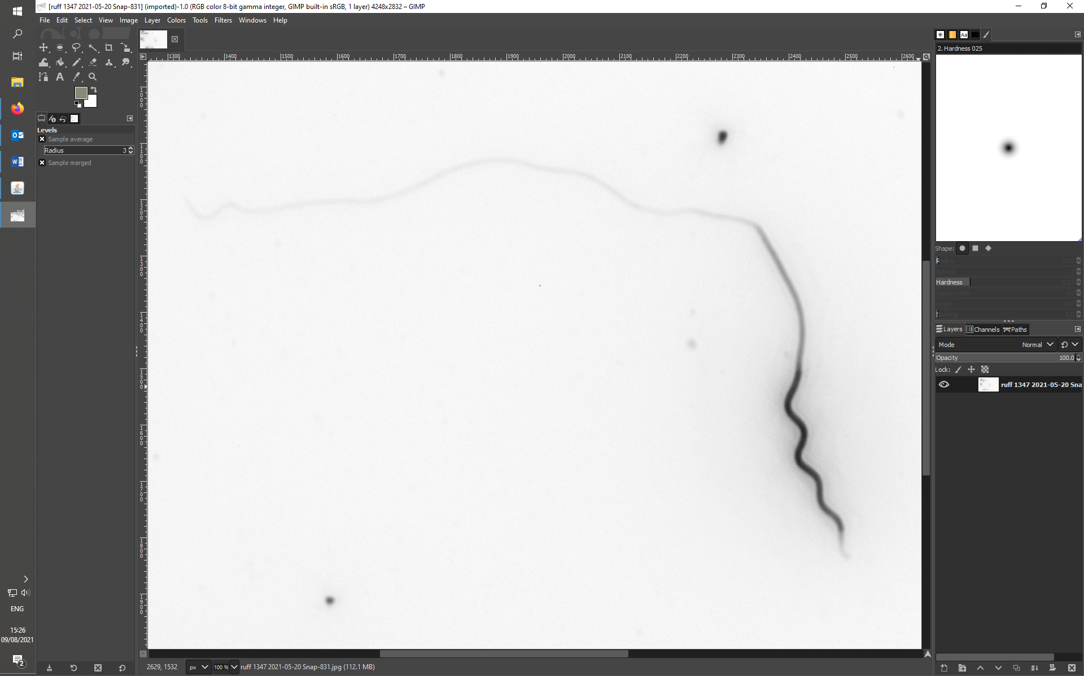 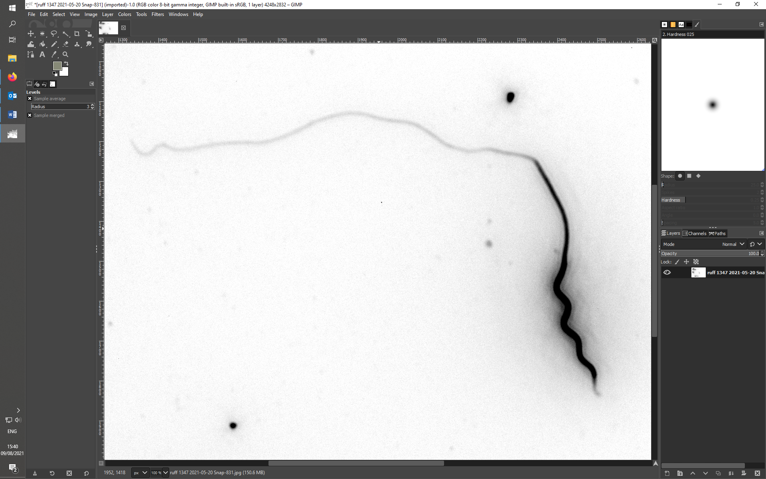

EXPORTING THE MEASUREMENTS

Once your measurement is complete, press “Export measurements”, which will save the measurements and pixtures of measurements into a folder with a data. Rename the folder by adding your initial (e.g. _MB for Martin Bulla) at the end.

# AFTER THAUGHT

Although placing a dot on a start of a tail might take some time, it seems to make things simpler. I now use a single-pixel red dot, but a bit larger dot (similar to sperm sizer one) might make the dot placement easier (as of now, I felt it is easier to locate the start of the tail in SpermSizer than in GIMP) or when the dot in GIMP is really just that and not a cross that is supposed to help to place the dot - I will have a look into that. Importantly, the longest part of the dot making process is the time GIMP takes to save the PNG. I have tried it with JPEG and that goes very fast. Thus, perhaps speed is more important here than keeping image quality. I would like to get your opinion on this (i.e. when you try it out in September).e) For sperm, where tail cannot be measured even on inverted and desaturated images. Cutting out the tail and erasing a bit of glow around the midpiece and parts of the tail results in a measurement.

CURREENTLY NOT USED

# Preparation of the image – on GIMP

Open one or more pictures, the .jpeg of the original pictures taken on the microscope.

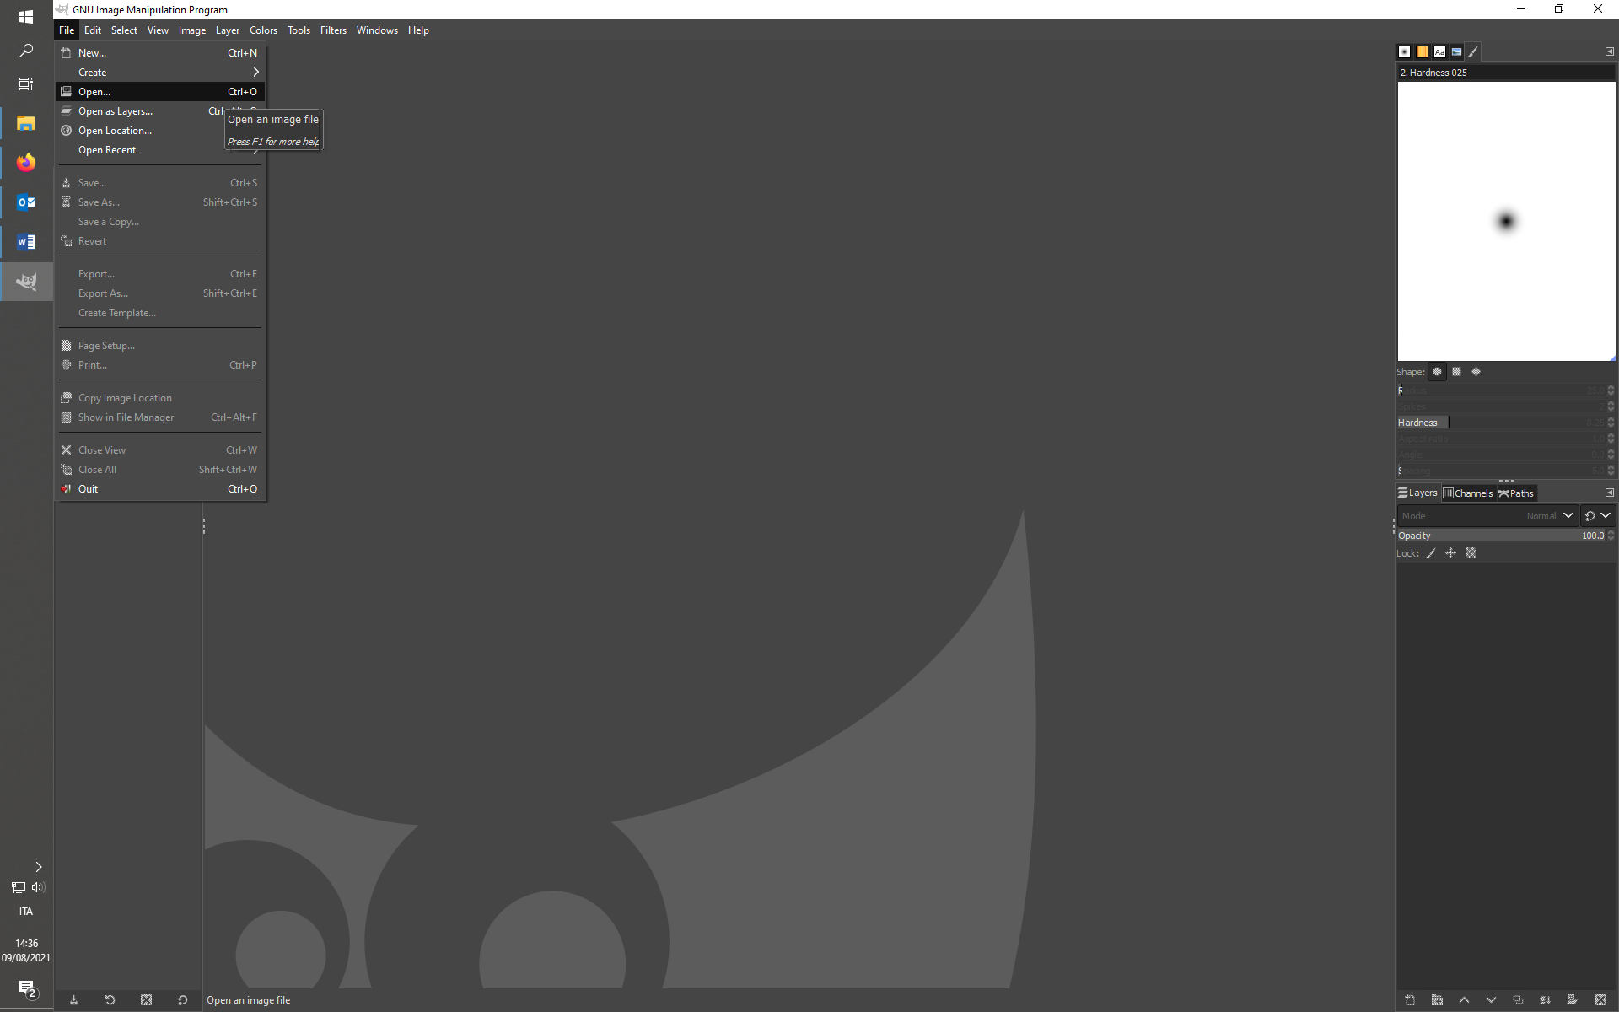

For each image, create an inverted version of the original picture.

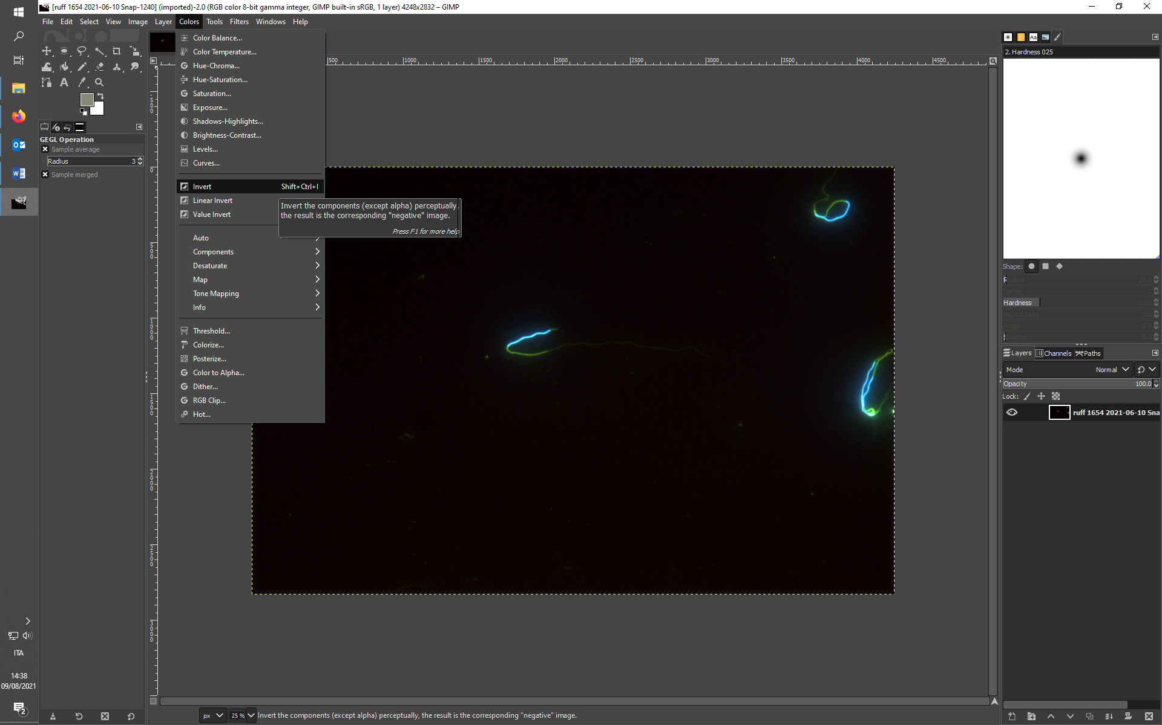

To speed the process, you can create a shortcut under Edit -> Keyboard shortcut. Then search the word “Invert” and create the preferred shortcut on the line of the G filters (as shown in the following screeshot).

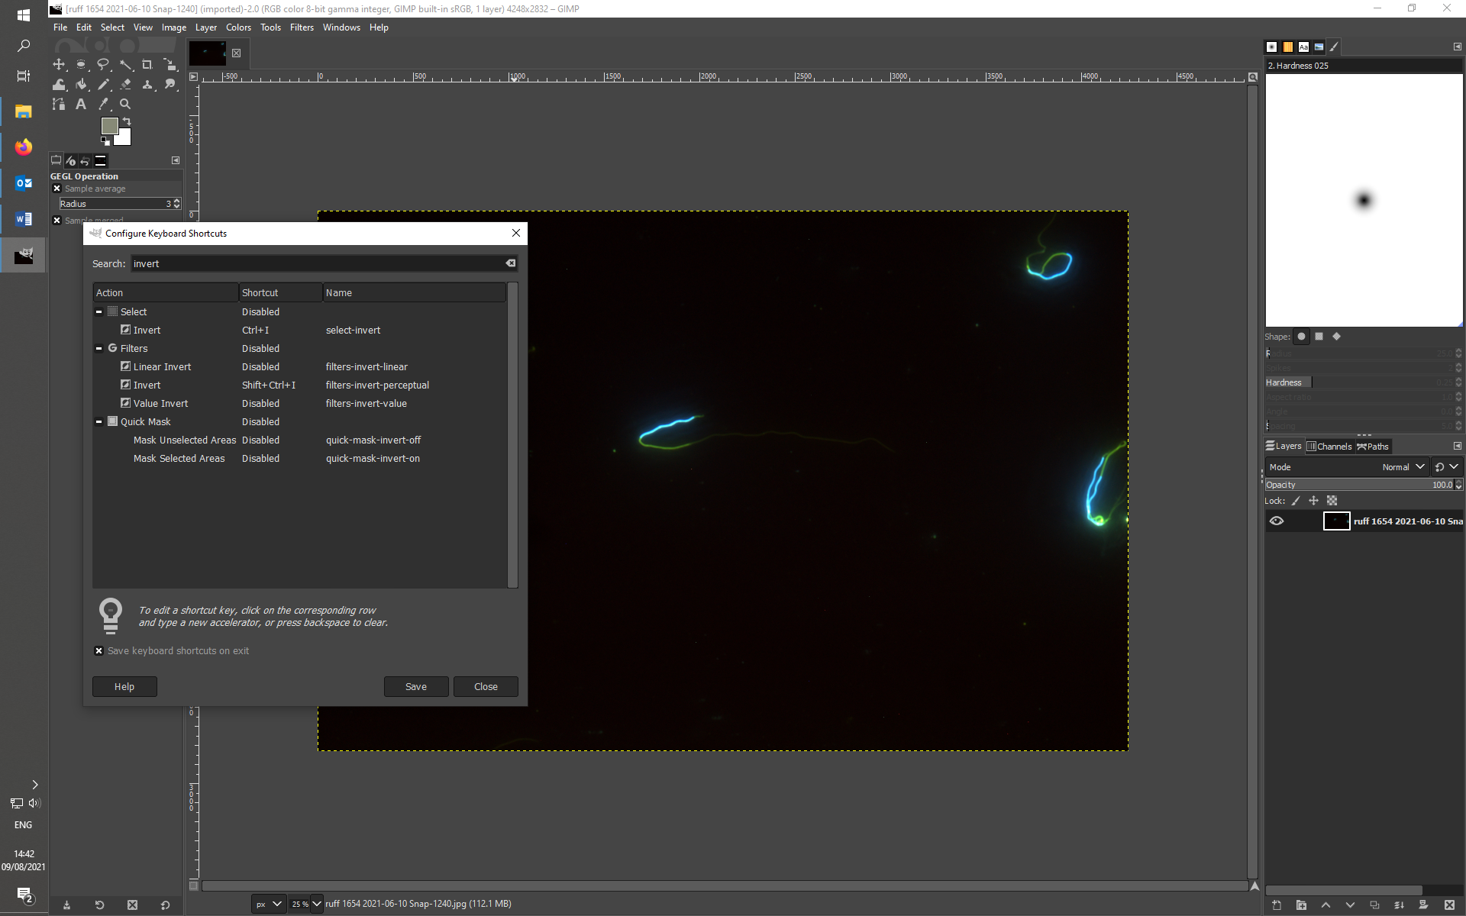

Once you have your inverted image, (1) place the dots at the starts and ends of each sperm part (for repeatability of SpermSizer in comparison to ImageJ) or (2) to place a dot at the start of tail so that you can start/end at the same spot when switching between inverted and desaturated images (see later). Then, export the image with “Export as”.

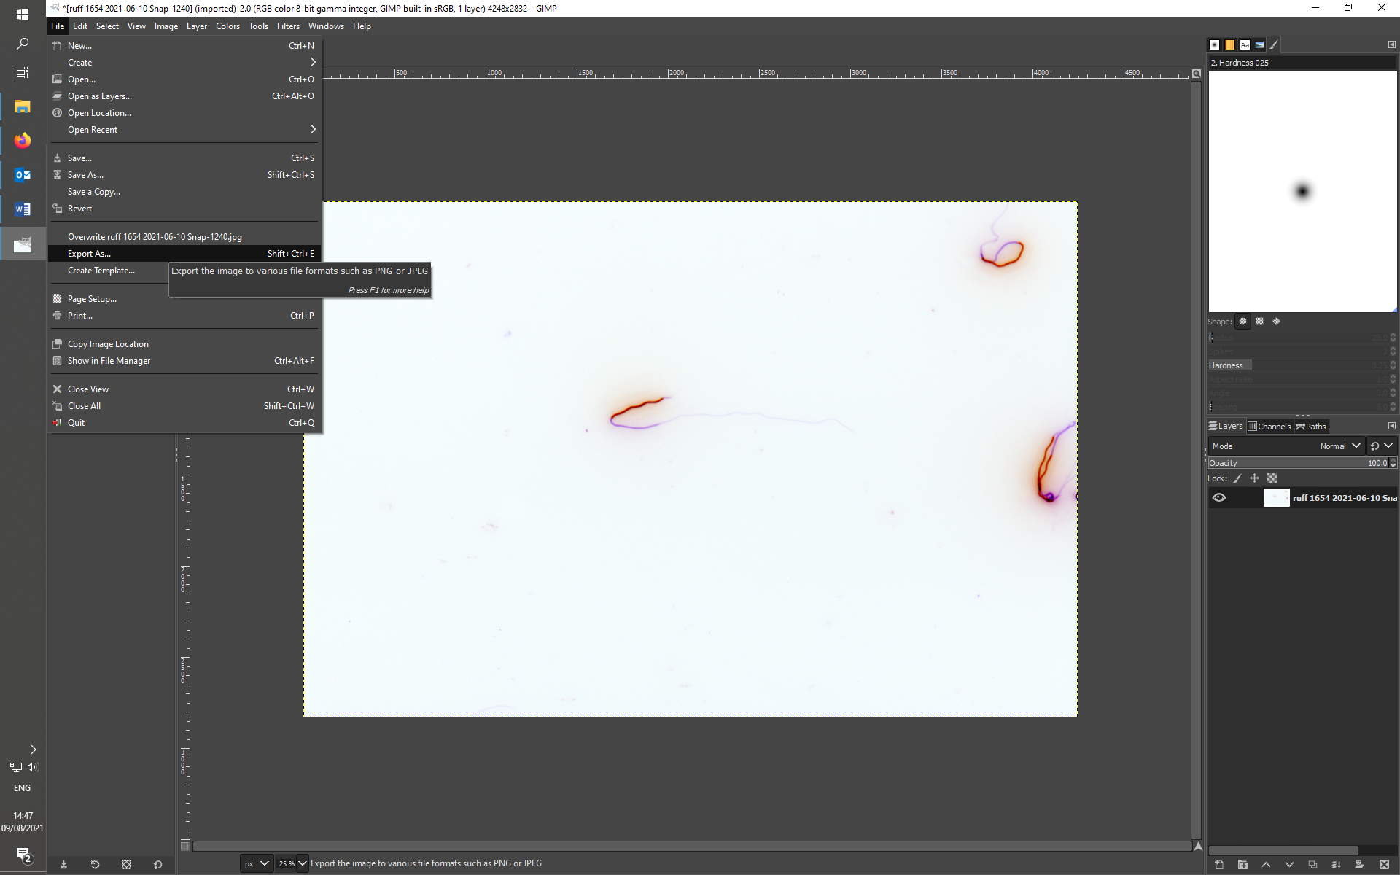

And save it as a PNG type of file by going on “Select File Type (By Extension)” and scrolling down to the wanted file type and add suffix “_inv”.

Once you’ve exported all your inverted pictures in a folder, create the desaturated pictures starting from the inverted ones you just saved. To do this, you can do as shown in the following screenshot, or once again you can create a Keyboard Shortcut to speed the process.

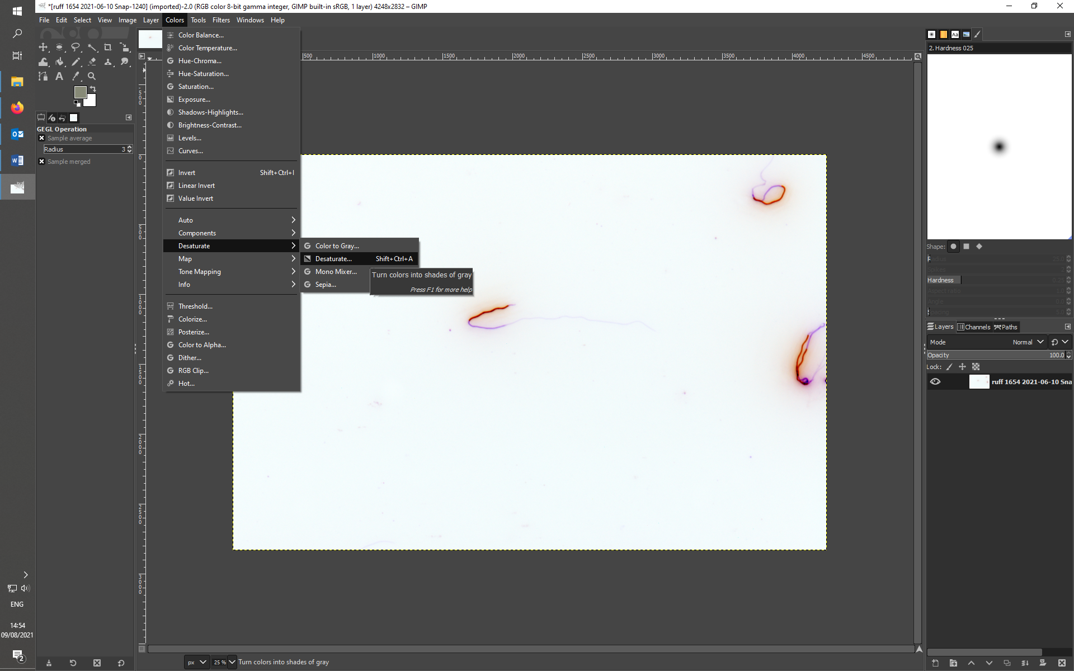

The following window will pop up, don’t make any changes and just press OK.

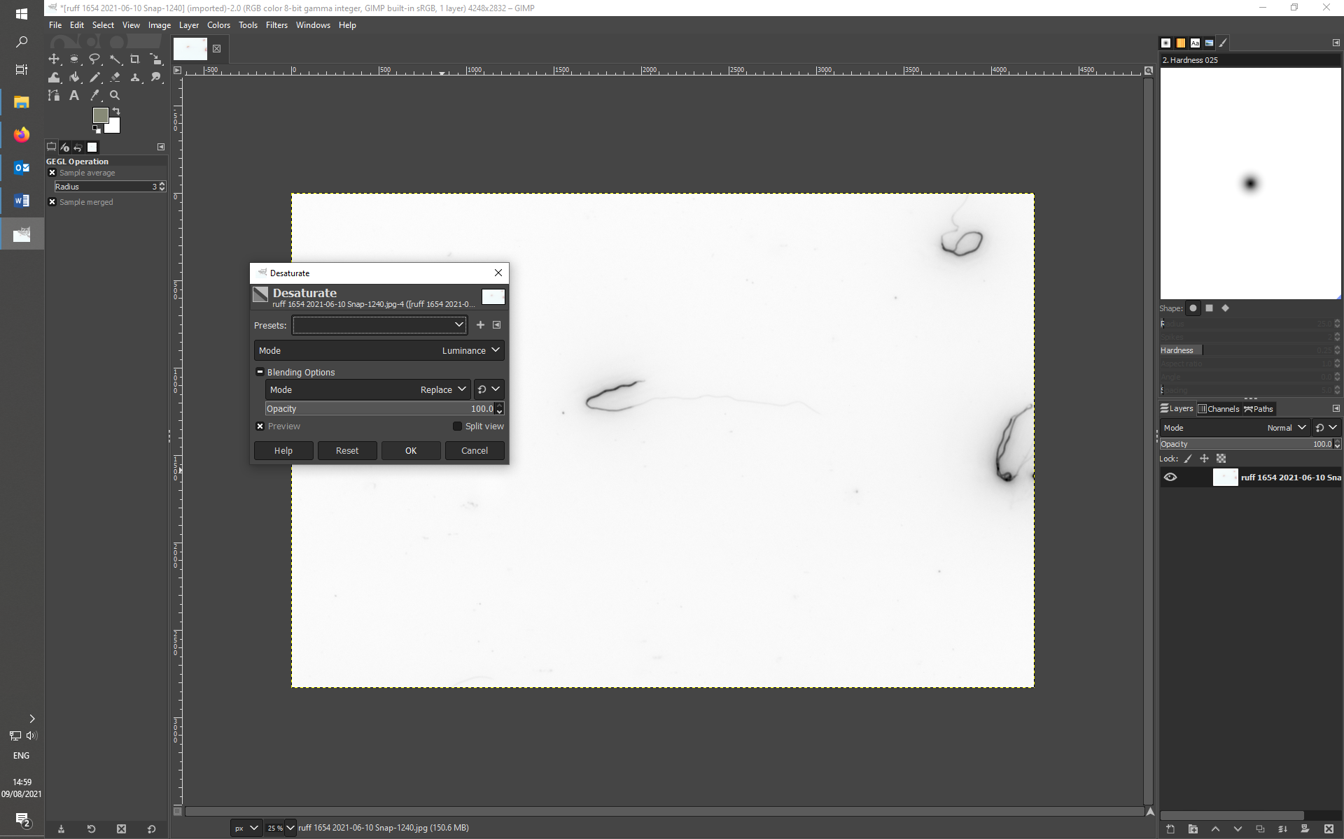

Once again export all the images you just created as PNG files and add suffix “_des”.